

JK Lakshmipat University

Computer Organization and Architecture
ASSIGNMENT 2

Name – Indrajit Roy
Section – B
Roll No.- 2023BTECH037
Date of Submission – 15th October, 2024
Submitted To – DR. Pranab Roy Sir

Question 1
Design a VHDL model for a hardwired 4-Bit comparator using dataflow architecture
Aim : To Design and implement a 4-bit comparator using the data flow architecture in VHDL to compare two 4-bit binary numbers (A and B) and to produce an output telling whether A is equal to, greater than, or less than B.
Block Diagram :
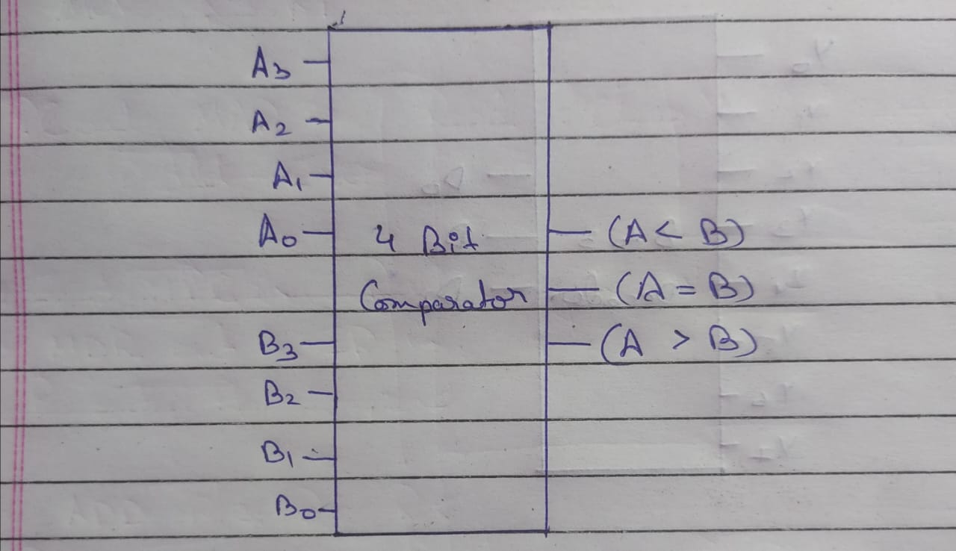
● VHDL Code:
----------------------------------------------------------------------------------
-- Company:
-- Engineer:
-- Create Date: 19:32:16 09/22/2024
-- Design Name:
-- Module Name: comparator - Behavioral
-- Project Name:
-- Target Devices:
-- Tool versions:
-- Description:
-- Dependencies:
-- Revision:
-- Revision 0.01 - File Created
-- Additional Comments:
---------------------------------------------------------------------------------
library IEEE;
use IEEE.STD_LOGIC_1164.ALL;
-- Uncomment the following library declaration if using
-- arithmetic functions with Signed or Unsigned values
--use IEEE.NUMERIC_STD.ALL;
-- Uncomment the following library declaration if instantiating
-- any Xilinx primitives in this code.
--library UNISIM;
--use UNISIM.VComponents.all;
entity comparator is
PORT(
A,B:IN STD_LOGIC_VECTOR(3 DOWNTO 0);
g,l,e: out std_logic);
end comparator;

architecture Behavioral of comparator is
signal s:std_logic_vector (3 downto 0);
begin
s(0)<=A(0) XNOR B(0);
s(1)<=A(1) XNOR B(1);
s(2)<=A(2) xNor B(2);
s(3)<=A(3) XNOR B(3);
g<=(A(3) AND NOT (B(3))) OR (s(3) and (A(2) AND (NOT B(2)))) OR(s(3) and s(2) and (A(1) AND (NOT (B(1))))) OR (s(3) and s(2) and s(1) and (A(0) AND (NOT B(0))));
l<=(NOT(A(3)) AND B(3)) OR (s(3) and (NOT(A(2)) AND B(2))) OR(s(3) and s(2) and (NOT (A(1)) AND (B(1)))) OR (s(3) and s(2) and s(1) and (NOT(A(0)) AND B(0)));
e<=(s(0) and s(1) and s(2) and s(3));
end Behavioral;
● RTL Diagram:
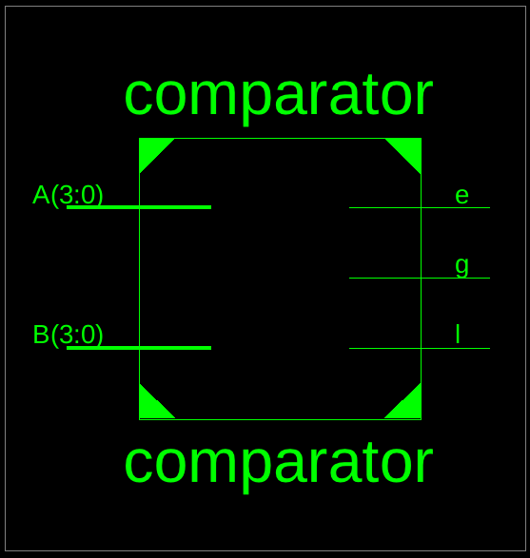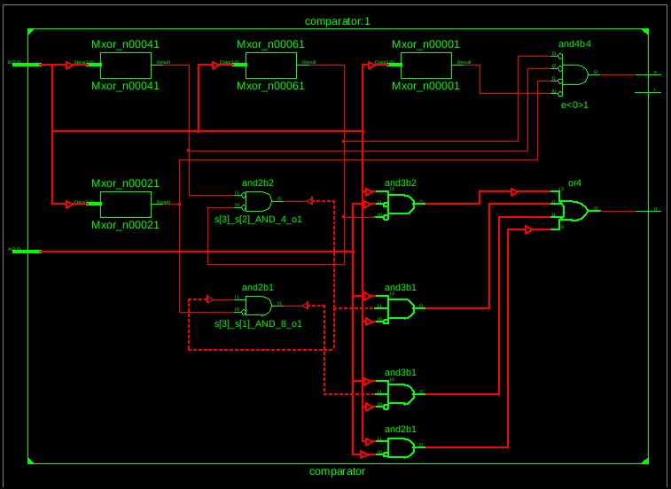
● Testbench Code:
--------------------------------------------------------------------------------
-- Company:
-- Engineer:
--
-- Create Date: 19:40:53 09/22/2024
-- Design Name:
-- Module Name: /home/ise/Assignment2/tb_comparator.vhd
-- Project Name: Assignment2
-- Target Device:
-- Tool versions:
-- Description:
--
-- VHDL Test Bench Created by ISE for module: comparator
--
-- Dependencies:
--
-- Revision:
-- Revision 0.01 - File Created
-- Additional Comments:
--
-- Notes:
-- This testbench has been automatically generated using types std_logic and
-- std_logic_vector for the ports of the unit under test. Xilinx recommends
-- that these types always be used for the top-level I/O of a design in order
-- to guarantee that the testbench will bind correctly to the post-implementation
-- simulation model.
--------------------------------------------------------------------------------
LIBRARY ieee;
USE ieee.std_logic_1164.ALL;

-- Uncomment the following library declaration if using
-- arithmetic functions with Signed or Unsigned values
--USE ieee.numeric_std.ALL;

ENTITY tb_comparator IS
END tb_comparator;

ARCHITECTURE behavior OF tb_comparator IS

-- Component Declaration for the Unit Under Test (UUT)

COMPONENT comparator
PORT(
A : IN std_logic_vector(3 downto 0);
B : IN std_logic_vector(3 downto 0);
g : OUT std_logic;
l : OUT std_logic;
e : OUT std_logic
);
END COMPONENT;
--Inputs
signal A : std_logic_vector(3 downto 0) := (others => '0');
signal B : std_logic_vector(3 downto 0) := (others => '0');
--Outputs
signal g : std_logic;
signal l : std_logic;
signal e : std_logic;
-- No clocks detected in port list. Replace <clock> below with
-- appropriate port name
BEGIN
-- Instantiate the Unit Under Test (UUT)
uut: comparator PORT MAP (
A => A,
B => B,
g => g,
l => l,
e => e
);
-- Stimulus process
stim_proc: process
begin
A <= "1001"; B <= "1000";
wait for 100 ns;
A <= "1101"; B <= "1101";
wait for 100 ns;
A <= "0000"; B <= "0001";
wait for 100 ns;
A <= "0000"; B <= "0000";
wait for 100 ns;
wait;
end process;
END;

● Waveform:
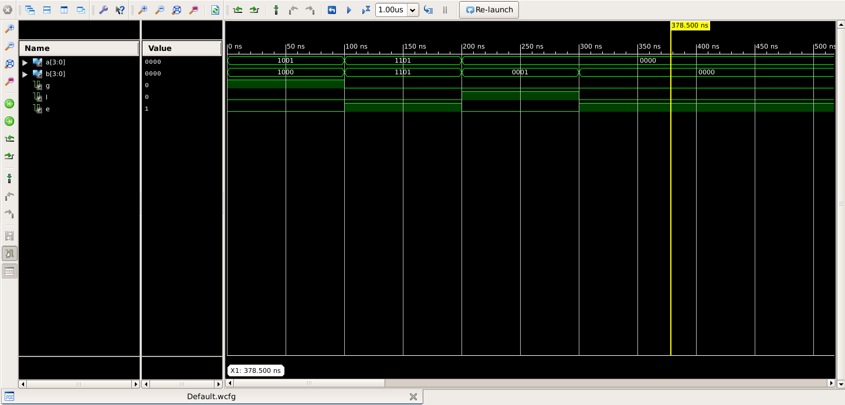
Question 2
Design a VHDL model for a 3 to 8 Decoder (with an enable) using Dataflow Architecture. Thereby Design a VHDL model for a 4 to 16 Decoder using 3 to 8 decoders designed earlier using Structural Architecture
Aim : To design a 3-to-8 Decoder with an enable signal using Dataflow Architecture and then use the designed 3-to-8 Decoder to create a 4-to-16 Decoder using Structural Architecture in VHDL.
Circuit Diagram :
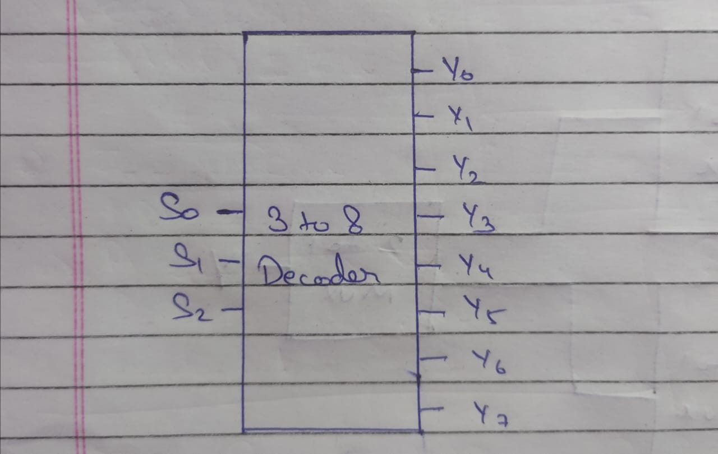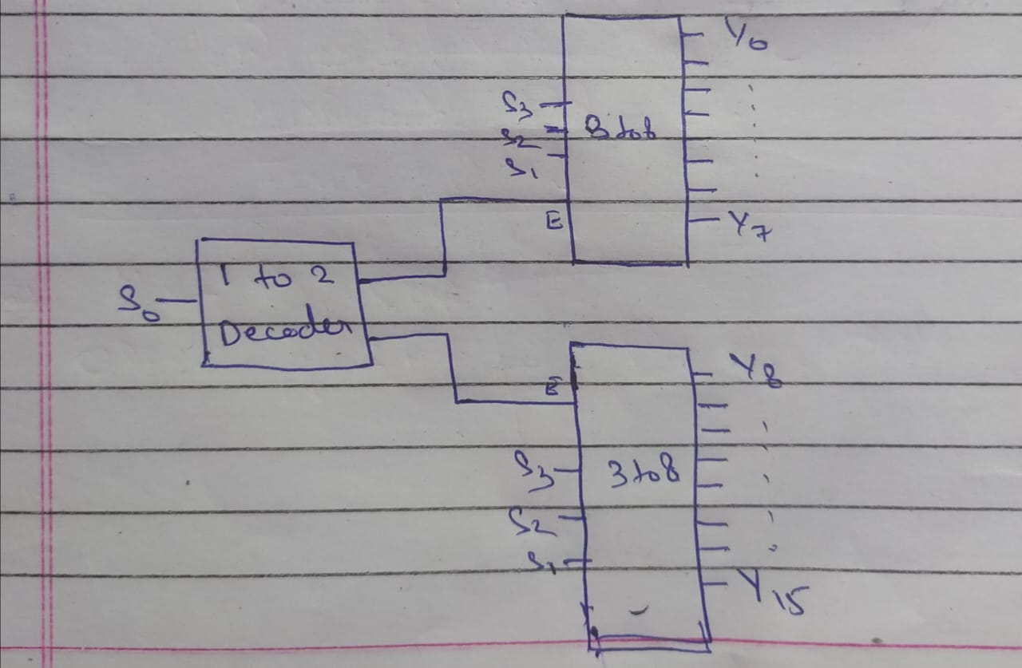
3 to 8 Decoder:
● VHDL Code:
----------------------------------------------------------------------------------
-- Company:
-- Engineer:
--
-- Create Date: 19:49:45 09/22/2024
-- Design Name:
-- Module Name: decoder_3_to_8 - Behavioral
-- Project Name:
-- Target Devices:
-- Tool versions:
-- Description:
--
-- Dependencies:
--
-- Revision:
-- Revision 0.01 - File Created
-- Additional Comments:
--
----------------------------------------------------------------------------------
library IEEE;
use IEEE.STD_LOGIC_1164.ALL;

-- Uncomment the following library declaration if using
-- arithmetic functions with Signed or Unsigned values
--use IEEE.NUMERIC_STD.ALL;

-- Uncomment the following library declaration if instantiating
-- any Xilinx primitives in this code.
--library UNISIM;
--use UNISIM.VComponents.all;

entity decoder_3_to_8 is
Port ( A : in STD_LOGIC_VECTOR (2 DOWNTO 0);
E : in STD_LOGIC;
Y : out STD_LOGIC_VECTOR (7 DOWNTO 0));
end decoder_3_to_8;

architecture Behavioral of decoder_3_to_8 is

begin
Y(0) <= (NOT A(0)) AND (NOT A(1)) AND (NOT A(2)) AND E;
Y(1) <= (NOT A(0)) AND (NOT A(1)) AND A(2) AND E;
Y(2) <= (NOT A(0)) AND A(1) AND (NOT A(2)) AND E;
Y(3) <= (NOT A(0)) AND A(1) AND A(2) AND E;
Y(4) <= A(0) AND (NOT A(1)) AND (NOT A(2)) AND E;
Y(5) <= A(0) AND (NOT A(1)) AND A(2) AND E;
Y(6) <= A(0) AND A(1) AND (NOT A(2)) AND E;
Y(7) <= A(0) AND A(1) AND A(2) AND E;
end Behavioral;

● RTL Diagram:
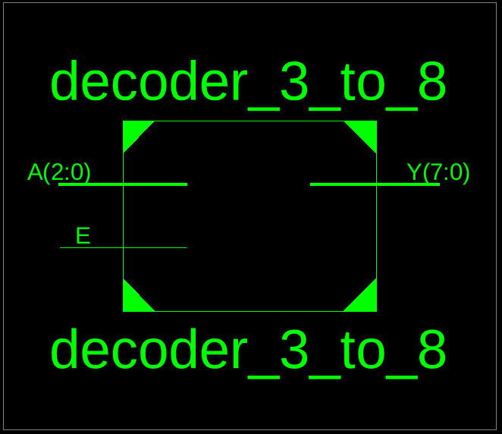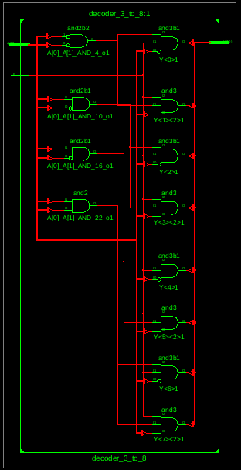
● Testbench Code:
--------------------------------------------------------------------------------
-- Company:
-- Engineer:
--
-- Create Date: 19:55:19 09/22/2024
-- Design Name:
-- Module Name: /home/ise/Assignment2/tb_decoder_3_to_8.vhd
-- Project Name: Assignment2
-- Target Device:
-- Tool versions:
-- Description:
--
-- VHDL Test Bench Created by ISE for module: decoder_3_to_8
--
-- Dependencies:
--
-- Revision:
-- Revision 0.01 - File Created
-- Additional Comments:
--
-- Notes:
-- This testbench has been automatically generated using types std_logic and
-- std_logic_vector for the ports of the unit under test. Xilinx recommends
-- that these types always be used for the top-level I/O of a design in order
-- to guarantee that the testbench will bind correctly to the post-implementation
-- simulation model.
--------------------------------------------------------------------------------
LIBRARY ieee;
USE ieee.std_logic_1164.ALL;

-- Uncomment the following library declaration if using
-- arithmetic functions with Signed or Unsigned values
--USE ieee.numeric_std.ALL;

ENTITY tb_decoder_3_to_8 IS
END tb_decoder_3_to_8;

ARCHITECTURE behavior OF tb_decoder_3_to_8 IS

-- Component Declaration for the Unit Under Test (UUT)

COMPONENT decoder_3_to_8
PORT(
A : IN std_logic_vector(2 downto 0);
E : IN std_logic;
Y : OUT std_logic_vector(7 downto 0)
);
END COMPONENT;

--Inputs
signal A : std_logic_vector(2 downto 0) := (others => '0');
signal E : std_logic := '0';

--Outputs
signal Y : std_logic_vector(7 downto 0);
-- No clocks detected in port list. Replace <clock> below with
-- appropriate port name

BEGIN

-- Instantiate the Unit Under Test (UUT)
uut: decoder_3_to_8 PORT MAP (
A => A,
E => E,
Y => Y
);

-- Stimulus process
stim_proc: process
begin
A <= "111";
E <= '1';
WAIT FOR 100 ns;
A <= "010";
E <= '1';
WAIT FOR 100 ns;
A <= "001";
E <= '1';
WAIT FOR 100 ns;

wait;
end process;

END;

● Waveform:
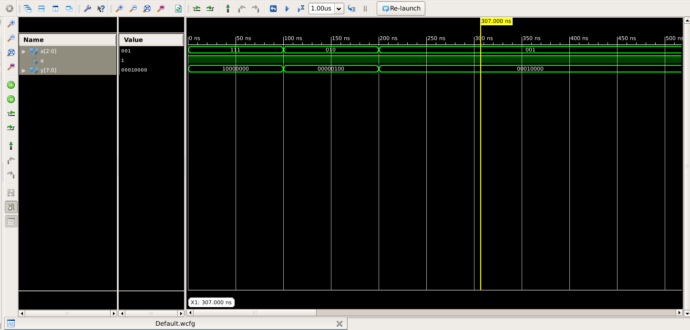
4 to 16 Decoder:
● VHDL Code:
----------------------------------------------------------------------------------
-- Company:
-- Engineer:
--
-- Create Date: 20:00:13 09/22/2024
-- Design Name:
-- Module Name: decoder_4_to_16 - Behavioral
-- Project Name:
-- Target Devices:
-- Tool versions:
-- Description:
--
-- Dependencies:
--
-- Revision:
-- Revision 0.01 - File Created
-- Additional Comments:
--
----------------------------------------------------------------------------------
library IEEE;
use IEEE.STD_LOGIC_1164.ALL;

-- Uncomment the following library declaration if using
-- arithmetic functions with Signed or Unsigned values
--use IEEE.NUMERIC_STD.ALL;

-- Uncomment the following library declaration if instantiating
-- any Xilinx primitives in this code.
--library UNISIM;
--use UNISIM.VComponents.all;

entity decoder_4_to_16 is
Port (
A : IN STD_LOGIC_VECTOR (3 DOWNTO 0);
E : in std_logic;
Y : OUT STD_LOGIC_VECTOR (15 DOWNTO 0)
);
end decoder_4_to_16;

architecture Behavioral of decoder_4_to_16 is
COMPONENT decoder_3_to_8 IS
Port (
A : IN STD_LOGIC_VECTOR (2 DOWNTO 0);
E : IN STD_LOGIC;
Y : OUT STD_LOGIC_VECTOR (7 DOWNTO 0)
);
END COMPONENT;
component decoder_1_to_2 is
Port ( Y : in STD_LOGIC;
E : in STD_LOGIC;
Y1 : out STD_LOGIC;
Y2 : out STD_LOGIC);
end component;
signal t1,t2: STD_LOGIC;

begin
step1:decoder_1_to_2 port map(A(0),E,t1,t2);
L1: decoder_3_to_8 PORT MAP (
A=> A(2 downto 0),
E => t1,
Y(0) => Y(0),
Y(1) => Y(1),
Y(2) => Y(2),
Y(3) => Y(3),
Y(4) => Y(4),
Y(5) => Y(5),
Y(6) => Y(6),
Y(7) => Y(7)
);
L2: decoder_3_to_8 PORT MAP (
A => A(2 DOWNTO 0),
E => t2,
Y(0) => Y(8),
Y(1) => Y(9),
Y(2) => Y(10),
Y(3) => Y(11),
Y(4) => Y(12),
Y(5) => Y(13),
Y(6) => Y(14),
Y(7) => Y(15)
);

end Behavioral;

● RTL Diagram:
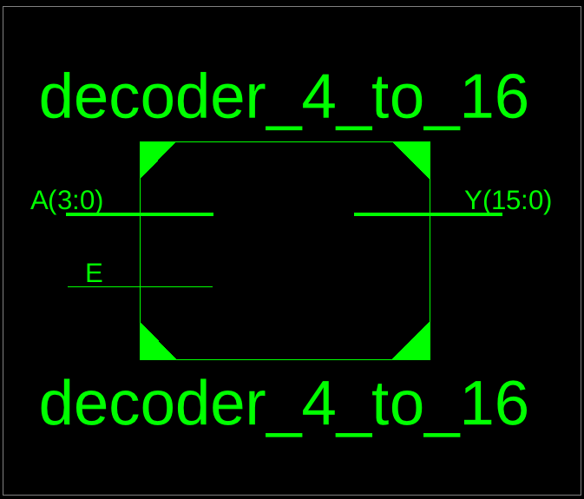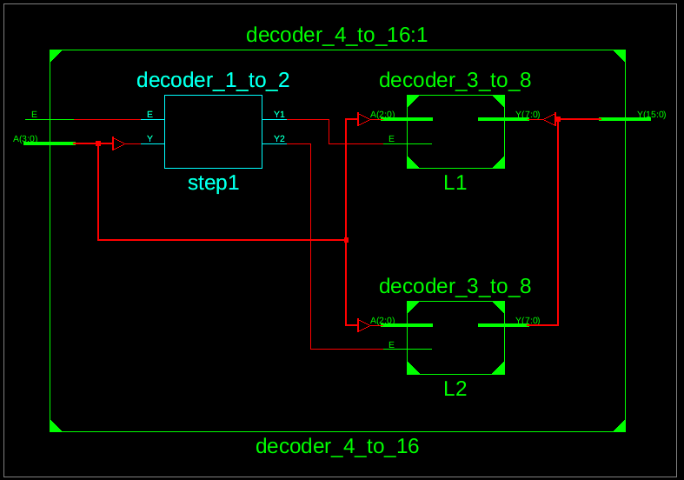
● Testbench Code:
--------------------------------------------------------------------------------
-- Company:
-- Engineer:
--
-- Create Date: 20:07:40 09/22/2024
-- Design Name:
-- Module Name: /home/ise/Assignment2/tb_decoder_4_to_16.vhd
-- Project Name: Assignment2
-- Target Device:
-- Tool versions:
-- Description:
--
-- VHDL Test Bench Created by ISE for module: decoder_4_to_16
--
-- Dependencies:
--
-- Revision:
-- Revision 0.01 - File Created
-- Additional Comments:
--
-- Notes:
-- This testbench has been automatically generated using types std_logic and
-- std_logic_vector for the ports of the unit under test. Xilinx recommends
-- that these types always be used for the top-level I/O of a design in order
-- to guarantee that the testbench will bind correctly to the post-implementation
-- simulation model.
--------------------------------------------------------------------------------
LIBRARY ieee;
USE ieee.std_logic_1164.ALL;

-- Uncomment the following library declaration if using
-- arithmetic functions with Signed or Unsigned values
--USE ieee.numeric_std.ALL;

ENTITY tb_decoder_4_to_16 IS
END tb_decoder_4_to_16;

ARCHITECTURE behavior OF tb_decoder_4_to_16 IS

-- Component Declaration for the Unit Under Test (UUT)

COMPONENT decoder_4_to_16
PORT(
A : IN std_logic_vector(3 downto 0);
E : IN std_logic;
Y : OUT std_logic_vector(15 downto 0)
);
END COMPONENT;

--Inputs
signal A : std_logic_vector(3 downto 0) := (others => '0');
signal E : std_logic := '0';

--Outputs
signal Y : std_logic_vector(15 downto 0);
-- No clocks detected in port list. Replace <clock> below with
-- appropriate port name

BEGIN

-- Instantiate the Unit Under Test (UUT)
uut: decoder_4_to_16 PORT MAP (
A => A,
E => E,
Y => Y
);

-- Stimulus process
stim_proc: process
begin
E<='1';
A<="1111";
wait for 100 ns;

wait;
end process;

END;
● Waveform:
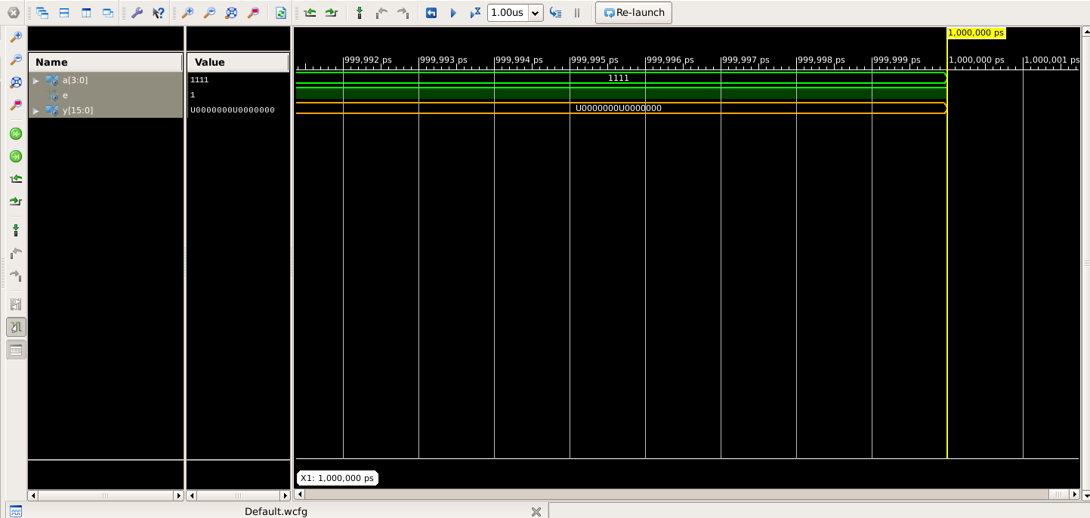

Question 3
Design a VHDL Model for an Octal to Binary Encoder with 8 input Bits and three output bits. Each input Bit represents one Octal number.
Aim : To design a VHDL model for an Octal-to-Binary Encoder with 8 input bits and 3 output bits, where each input bit represents an octal number.
Block Diagram :
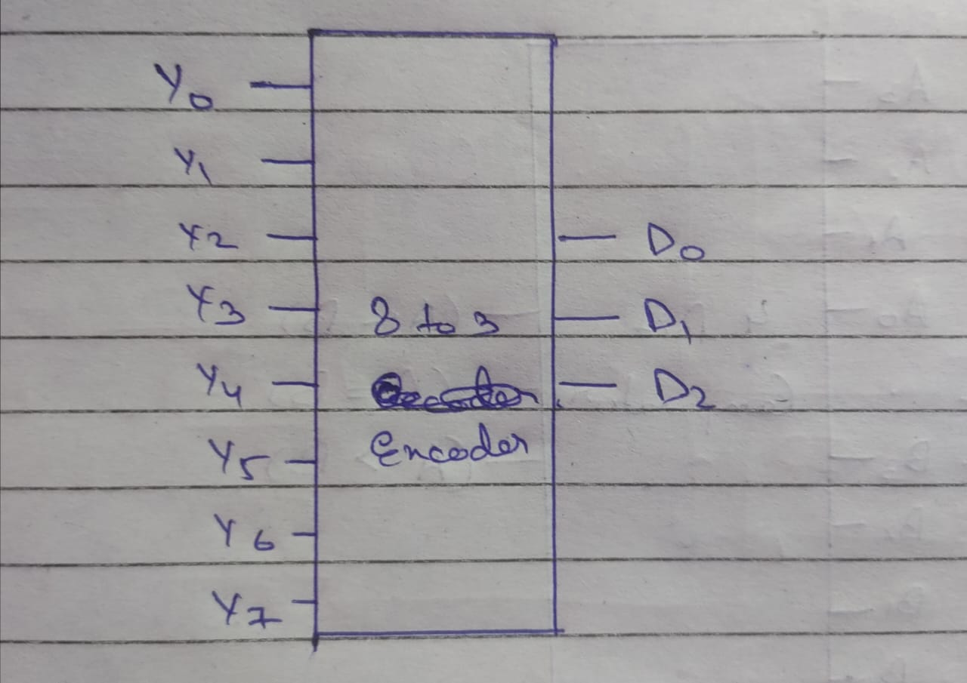
● VHDL Code:
----------------------------------------------------------------------------------
-- Company:
-- Engineer:
--
-- Create Date: 20:16:54 09/22/2024
-- Design Name:
-- Module Name: octal_to_binary - Behavioral
-- Project Name:
-- Target Devices:
-- Tool versions:
-- Description:
--
-- Dependencies:
--
-- Revision:
-- Revision 0.01 - File Created
-- Additional Comments:
--
----------------------------------------------------------------------------------
library IEEE;
use IEEE.STD_LOGIC_1164.ALL;

-- Uncomment the following library declaration if using
-- arithmetic functions with Signed or Unsigned values
--use IEEE.NUMERIC_STD.ALL;

-- Uncomment the following library declaration if instantiating
-- any Xilinx primitives in this code.
--library UNISIM;
--use UNISIM.VComponents.all;

entity octal_to_binary is
Port ( A : in STD_LOGIC;
B : in STD_LOGIC;
C : in STD_LOGIC;
D : in STD_LOGIC;
E : in STD_LOGIC;
F : in STD_LOGIC;
G : in STD_LOGIC;
H : in STD_LOGIC;
EN : in STD_LOGIC;
Y0 : out STD_LOGIC;
Y1 : out STD_LOGIC;
Y2 : out STD_LOGIC);
end octal_to_binary;

architecture Behavioral of octal_to_binary is

begin
Y0<=(B OR D OR F OR H )AND EN;
Y1<= (C OR D OR G OR H) AND EN;
Y2 <= (E OR F OR G OR H) AND EN;

end Behavioral;
● RTL Diagram:
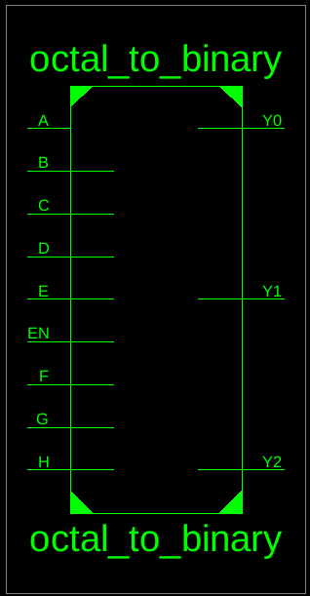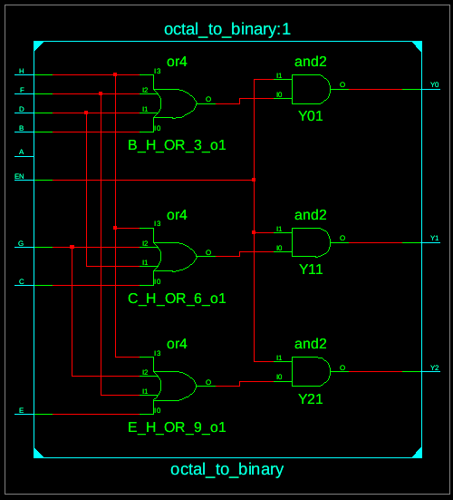
● Testbench Code:
--------------------------------------------------------------------------------
-- Company:
-- Engineer:
--
-- Create Date: 20:21:55 09/22/2024
-- Design Name:
-- Module Name: /home/ise/Assignment2/tb_octal_to_binary.vhd
-- Project Name: Assignment2
-- Target Device:
-- Tool versions:
-- Description:
--
-- VHDL Test Bench Created by ISE for module: octal_to_binary
--
-- Dependencies:
--
-- Revision:
-- Revision 0.01 - File Created
-- Additional Comments:
--
-- Notes:
-- This testbench has been automatically generated using types std_logic and
-- std_logic_vector for the ports of the unit under test. Xilinx recommends
-- that these types always be used for the top-level I/O of a design in order
-- to guarantee that the testbench will bind correctly to the post-implementation
-- simulation model.
--------------------------------------------------------------------------------
LIBRARY ieee;
USE ieee.std_logic_1164.ALL;
-- Uncomment the following library declaration if using
-- arithmetic functions with Signed or Unsigned values
--USE ieee.numeric_std.ALL;
ENTITY tb_octal_to_binary IS
END tb_octal_to_binary;
ARCHITECTURE behavior OF tb_octal_to_binary IS
-- Component Declaration for the Unit Under Test (UUT)
COMPONENT octal_to_binary
PORT(
A : IN std_logic;
B : IN std_logic;
C : IN std_logic;
D : IN std_logic;
E : IN std_logic;
F : IN std_logic;
G : IN std_logic;
H : IN std_logic;
EN : IN std_logic;
Y0 : OUT std_logic;
Y1 : OUT std_logic;
Y2 : OUT std_logic
);
END COMPONENT;
--Inputs
signal A : std_logic := '0';
signal B : std_logic := '0';
signal C : std_logic := '0';
signal D : std_logic := '0';
signal E : std_logic := '0';
signal F : std_logic := '0';
signal G : std_logic := '0';
signal H : std_logic := '0';
signal EN : std_logic := '0';
--Outputs
signal Y0 : std_logic;
signal Y1 : std_logic;
signal Y2 : std_logic;
-- No clocks detected in port list. Replace <clock> below with
-- appropriate port name
BEGIN
-- Instantiate the Unit Under Test (UUT)
uut: octal_to_binary PORT MAP (
A => A,
B => B,
C => C,
D => D,
E => E,
F => F,
G => G,
H => H,
EN => EN,
Y0 => Y0,
Y1 => Y1,
Y2 => Y2
);
-- Stimulus process
stim_proc: process
begin
A <= '0'; B <= '0'; C <= '0'; D <= '0'; E <= '1'; F <= '1'; G <= '0'; H <= '0';
wait for 10 ns;
wait;
end process;
END;
● Waveform:
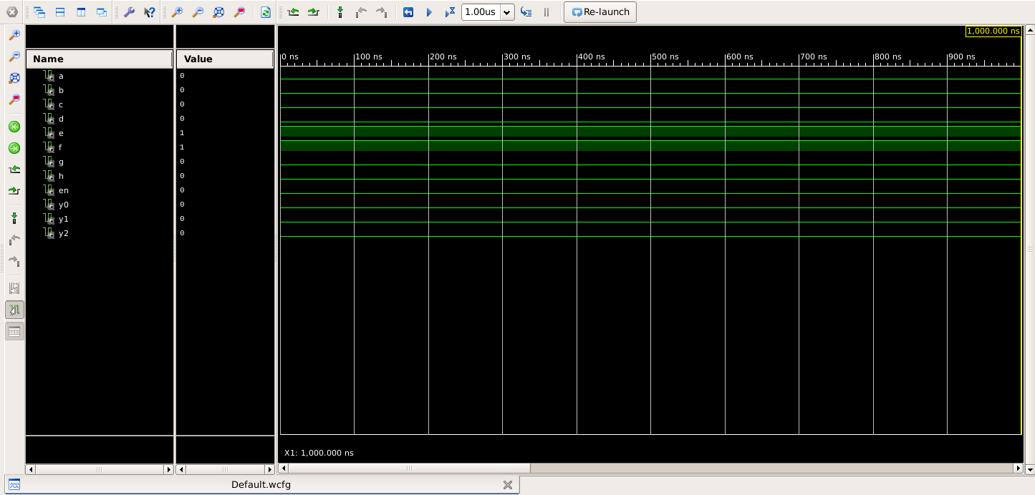
Question 4
Design a VHDL model for 8-1 and 2-1 multiplexer. Using these models develop a VHDL model for 16 -1 multiplexer (Use structural architecture).
Aim : To design VHDL models for an 8-to-1 multiplexer (MUX) and a 2-to-1 multiplexer, and use these models to develop a 16-to-1 multiplexer using Structural Architecture.
Block Diagram :
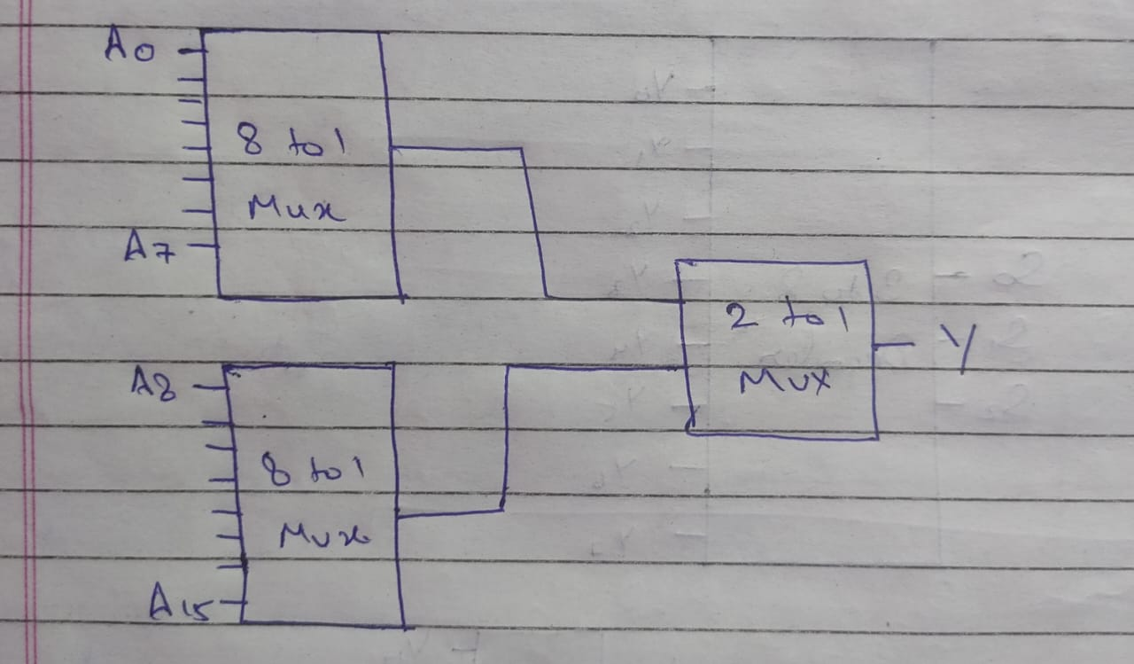
8 To 1 Multiplexer:
● VHDL Code:
----------------------------------------------------------------------------------
-- Company:
-- Engineer:
--
-- Create Date: 20:26:12 09/22/2024
-- Design Name:
-- Module Name: mux_8_to_1 - Behavioral
-- Project Name:
-- Target Devices:
-- Tool versions:
-- Description:
--
-- Dependencies:
--
-- Revision:
-- Revision 0.01 - File Created
-- Additional Comments:
--
----------------------------------------------------------------------------------
library IEEE;
use IEEE.STD_LOGIC_1164.ALL;

-- Uncomment the following library declaration if using
-- arithmetic functions with Signed or Unsigned values
--use IEEE.NUMERIC_STD.ALL;

-- Uncomment the following library declaration if instantiating
-- any Xilinx primitives in this code.
--library UNISIM;
--use UNISIM.VComponents.all;

entity mux_8_to_1 is
Port ( A : in STD_LOGIC_VECTOR (7 downto 0);
S1,S2,S3: IN STD_LOGIC;
Y : out STD_LOGIC);
end mux_8_to_1;

architecture Behavioral of mux_8_to_1 is

begin
Y<=((NOT (S1) AND NOT(S2) AND NOT (S3) AND A(0)) OR (NOT (S1) AND NOT (S2) AND S3 AND A(1)) OR (NOT(S1) AND S2 AND NOT(S3) AND A(2)) OR (NOT (S1) AND S2 AND S3 AND A(3)) OR (S1 AND NOT(S2) AND NOT(S2) AND A(4)) OR (S1 AND NOT (S2) AND S3 AND A(5)) OR (S1 AND S2 AND NOT(S3) AND A(6)) OR(S1 AND S2 AND S3 AND A(7)));

end Behavioral;

● RTL Diagram:
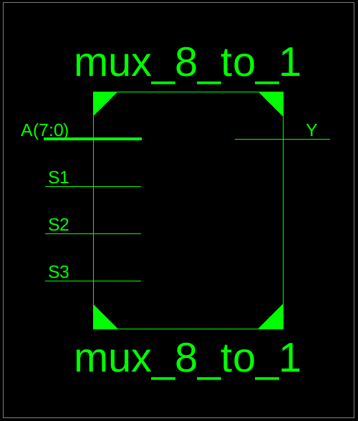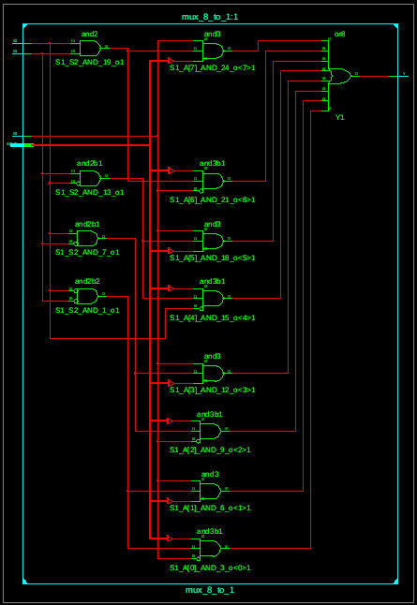

● Testbench Code:
--------------------------------------------------------------------------------
-- Company:
-- Engineer:
--
-- Create Date: 20:38:44 09/22/2024
-- Design Name:
-- Module Name: /home/ise/Assignment2/tb_mux_8_to_1.vhd
-- Project Name: Assignment2
-- Target Device:
-- Tool versions:
-- Description:
--
-- VHDL Test Bench Created by ISE for module: mux_8_to_1
--
-- Dependencies:
--
-- Revision:
-- Revision 0.01 - File Created
-- Additional Comments:
--
-- Notes:
-- This testbench has been automatically generated using types std_logic and
-- std_logic_vector for the ports of the unit under test. Xilinx recommends
-- that these types always be used for the top-level I/O of a design in order
-- to guarantee that the testbench will bind correctly to the post-implementation
-- simulation model.
--------------------------------------------------------------------------------
LIBRARY ieee;
USE ieee.std_logic_1164.ALL;

-- Uncomment the following library declaration if using
-- arithmetic functions with Signed or Unsigned values
--USE ieee.numeric_std.ALL;

ENTITY tb_mux_8_to_1 IS
END tb_mux_8_to_1;

ARCHITECTURE behavior OF tb_mux_8_to_1 IS

-- Component Declaration for the Unit Under Test (UUT)

COMPONENT mux_8_to_1
PORT(
A : IN std_logic_vector(7 downto 0);
S1 : IN std_logic;
S2 : IN std_logic;
S3 : IN std_logic;
Y : OUT std_logic
);
END COMPONENT;

--Inputs
signal A : std_logic_vector(7 downto 0) := (others => '0');
signal S1 : std_logic := '0';
signal S2 : std_logic := '0';
signal S3 : std_logic := '0';

--Outputs
signal Y : std_logic;
-- No clocks detected in port list. Replace <clock> below with
-- appropriate port name

BEGIN

-- Instantiate the Unit Under Test (UUT)
uut: mux_8_to_1 PORT MAP (
A => A,
S1 => S1,
S2 => S2,
S3 => S3,
Y => Y
);

-- Stimulus process
stim_proc: process
begin
A<="00101110";
S1<='1';S2<='1';S3<='1';
wait for 100 ns;

wait;
end process;

END;

● Waveform:
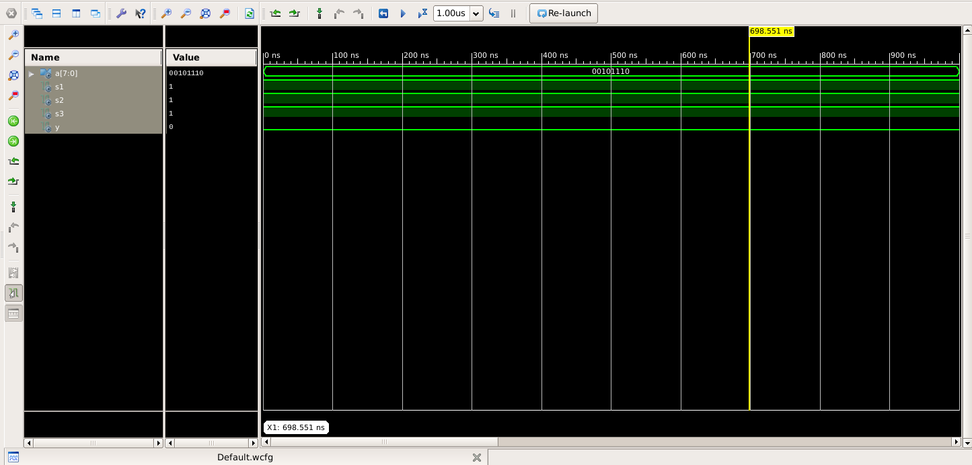
2 To 1 Multiplexer:
● VHDL Code:
----------------------------------------------------------------------------------
-- Company:
-- Engineer:
--
-- Create Date: 20:42:59 09/22/2024
-- Design Name:
-- Module Name: mux_2_to_1 - Behavioral
-- Project Name:
-- Target Devices:
-- Tool versions:
-- Description:
--
-- Dependencies:
--
-- Revision:
-- Revision 0.01 - File Created
-- Additional Comments:
--
----------------------------------------------------------------------------------
library IEEE;
use IEEE.STD_LOGIC_1164.ALL;

-- Uncomment the following library declaration if using
-- arithmetic functions with Signed or Unsigned values
--use IEEE.NUMERIC_STD.ALL;

-- Uncomment the following library declaration if instantiating
-- any Xilinx primitives in this code.
--library UNISIM;
--use UNISIM.VComponents.all;

entity mux_2_to_1 is
Port ( A : in STD_LOGIC;
B : in STD_LOGIC;
S1 : in STD_LOGIC;
Y : out STD_LOGIC);
end mux_2_to_1;

architecture Behavioral of mux_2_to_1 is

begin
Y<=(A AND NOT(S1)) OR (B AND S1);
end Behavioral;
● RTL Diagram:
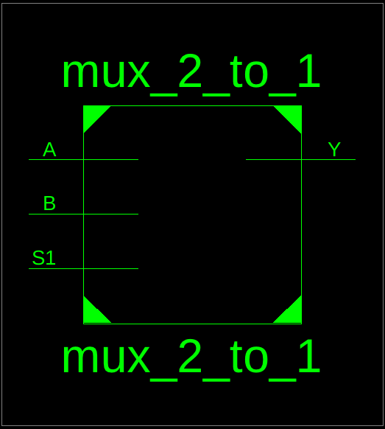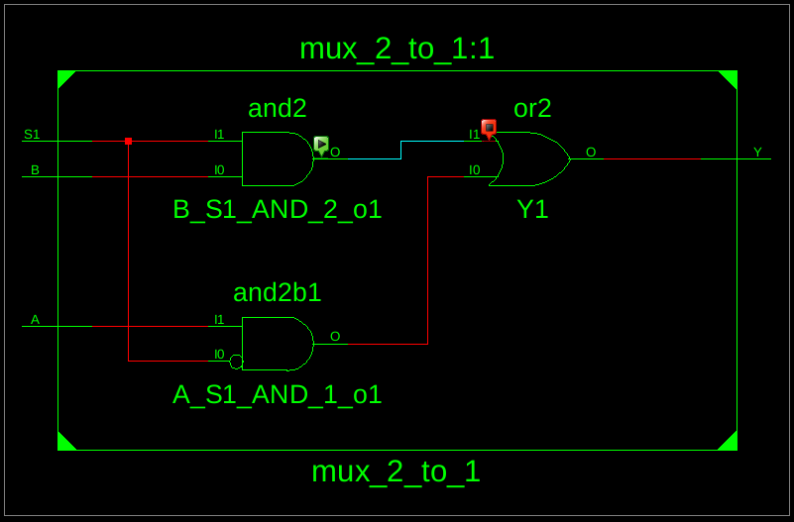

● Testbench Code:
--------------------------------------------------------------------------------
-- Company:
-- Engineer:
--
-- Create Date: 20:45:40 09/22/2024
-- Design Name:
-- Module Name: /home/ise/Assignment2/tb_mux_2_to_1.vhd
-- Project Name: Assignment2
-- Target Device:
-- Tool versions:
-- Description:
--
-- VHDL Test Bench Created by ISE for module: mux_2_to_1
--
-- Dependencies:
--
-- Revision:
-- Revision 0.01 - File Created
-- Additional Comments:
--
-- Notes:
-- This testbench has been automatically generated using types std_logic and
-- std_logic_vector for the ports of the unit under test. Xilinx recommends
-- that these types always be used for the top-level I/O of a design in order
-- to guarantee that the testbench will bind correctly to the post-implementation
-- simulation model.
--------------------------------------------------------------------------------
LIBRARY ieee;
USE ieee.std_logic_1164.ALL;

-- Uncomment the following library declaration if using
-- arithmetic functions with Signed or Unsigned values
--USE ieee.numeric_std.ALL;

ENTITY tb_mux_2_to_1 IS
END tb_mux_2_to_1;

ARCHITECTURE behavior OF tb_mux_2_to_1 IS

-- Component Declaration for the Unit Under Test (UUT)

COMPONENT mux_2_to_1
PORT(
A : IN std_logic;
B : IN std_logic;
S1 : IN std_logic;
Y : OUT std_logic
);
END COMPONENT;

--Inputs
signal A : std_logic := '0';
signal B : std_logic := '0';
signal S1 : std_logic := '0';

--Outputs
signal Y : std_logic;
-- No clocks detected in port list. Replace <clock> below with
-- appropriate port name

BEGIN

-- Instantiate the Unit Under Test (UUT)
uut: mux_2_to_1 PORT MAP (
A => A,
B => B,
S1 => S1,
Y => Y
);

-- Stimulus process
stim_proc: process
begin
A<='1';B<='0';S1<='1';

wait;
end process;

END;
● Waveform:

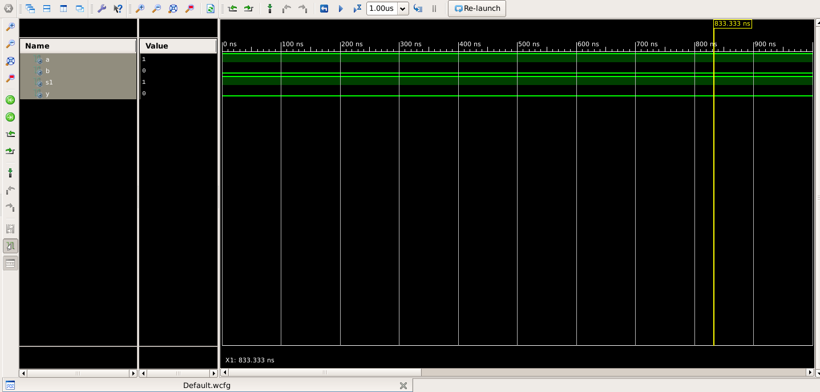

16 To 1 Multiplexer:
● VHDL Code:
----------------------------------------------------------------------------------
-- Company:
-- Engineer:
--
-- Create Date: 20:50:00 09/22/2024
-- Design Name:
-- Module Name: mux_16_to_1 - Behavioral
-- Project Name:
-- Target Devices:
-- Tool versions:
-- Description:
--
-- Dependencies:
--
-- Revision:
-- Revision 0.01 - File Created
-- Additional Comments:
--
----------------------------------------------------------------------------------
library IEEE;
use IEEE.STD_LOGIC_1164.ALL;

-- Uncomment the following library declaration if using
-- arithmetic functions with Signed or Unsigned values
--use IEEE.NUMERIC_STD.ALL;

-- Uncomment the following library declaration if instantiating
-- any Xilinx primitives in this code.
--library UNISIM;
--use UNISIM.VComponents.all;

entity mux_16_to_1 is
Port ( A : in STD_LOGIC_VECTOR (15 downto 0);
S : in STD_LOGIC_VECTOR (3 downto 0);
Y : out STD_LOGIC);
end mux_16_to_1;

architecture Behavioral of mux_16_to_1 is
component mux_8_to_1 is
Port (
A : in STD_LOGIC_VECTOR (7 downto 0);
S1,S2,S3: IN STD_LOGIC;
Y : out STD_LOGIC);
end component;
component mux_2_to_1 is
Port (
A : in STD_LOGIC;
B : in STD_LOGIC;
S1 : in STD_LOGIC;
Y : out STD_LOGIC);
end component;
signal t1,t2:std_logic;
begin
step1:mux_8_to_1 port map (A=>A(7 DOWNTO 0),S1=>S(0),S2=>S(1),S3=>S(2),Y=>t1);
step2:mux_8_to_1 port map (A=>A(15 DOWNTO 8),S1=>S(0),S2=>S(1),S3=>S(2),Y=>t2);
step3:mux_2_to_1 port map(A=>t1,B=>t2,S1=>S(3),Y=>Y);
end Behavioral;
● RTL Diagram:
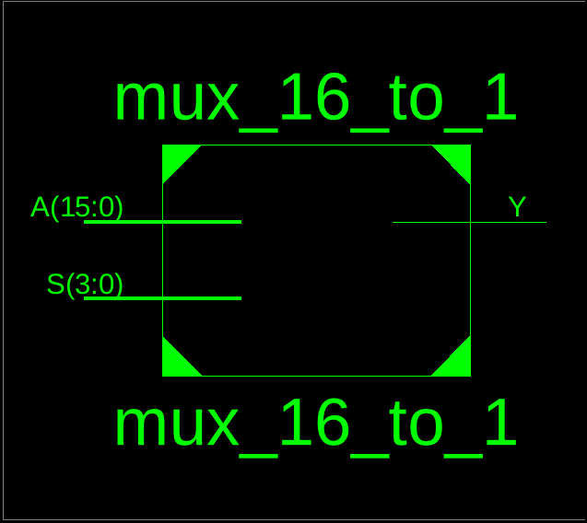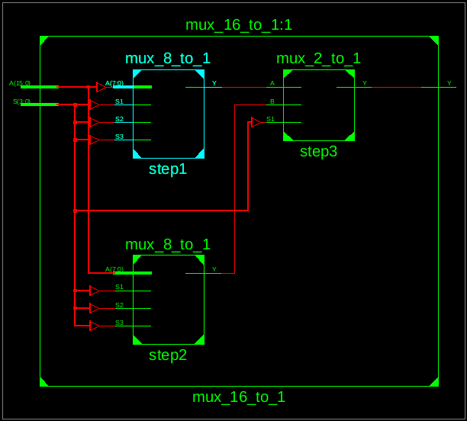

● Testbench Code:
--------------------------------------------------------------------------------
-- Company:
-- Engineer:
--
-- Create Date: 20:58:19 09/22/2024
-- Design Name:
-- Module Name: /home/ise/Assignment2/tb_mux_16_to_1.vhd
-- Project Name: Assignment2
-- Target Device:
-- Tool versions:
-- Description:
--
-- VHDL Test Bench Created by ISE for module: mux_16_to_1
--
-- Dependencies:
--
-- Revision:
-- Revision 0.01 - File Created
-- Additional Comments:
--
-- Notes:
-- This testbench has been automatically generated using types std_logic and
-- std_logic_vector for the ports of the unit under test. Xilinx recommends
-- that these types always be used for the top-level I/O of a design in order
-- to guarantee that the testbench will bind correctly to the post-implementation
-- simulation model.
--------------------------------------------------------------------------------
LIBRARY ieee;
USE ieee.std_logic_1164.ALL;

-- Uncomment the following library declaration if using
-- arithmetic functions with Signed or Unsigned values
--USE ieee.numeric_std.ALL;

ENTITY tb_mux_16_to_1 IS
END tb_mux_16_to_1;

ARCHITECTURE behavior OF tb_mux_16_to_1 IS
-- Component Declaration for the Unit Under Test (UUT)
COMPONENT mux_16_to_1
PORT(
A : IN std_logic_vector(15 downto 0);
S : IN std_logic_vector(3 downto 0);
Y : OUT std_logic
);
END COMPONENT;
--Inputs
signal A : std_logic_vector(15 downto 0) := (others => '0');
signal S : std_logic_vector(3 downto 0) := (others => '0');
--Outputs
signal Y : std_logic;
-- No clocks detected in port list. Replace <clock> below with
-- appropriate port name
BEGIN
-- Instantiate the Unit Under Test (UUT)
uut: mux_16_to_1 PORT MAP (
A => A,
S => S,
Y => Y
);
-- Stimulus process
stim_proc: process
begin
A<="1000000010000000";
S<="1111";
wait for 100 ns;
wait;
end process;

END;
● Waveform:

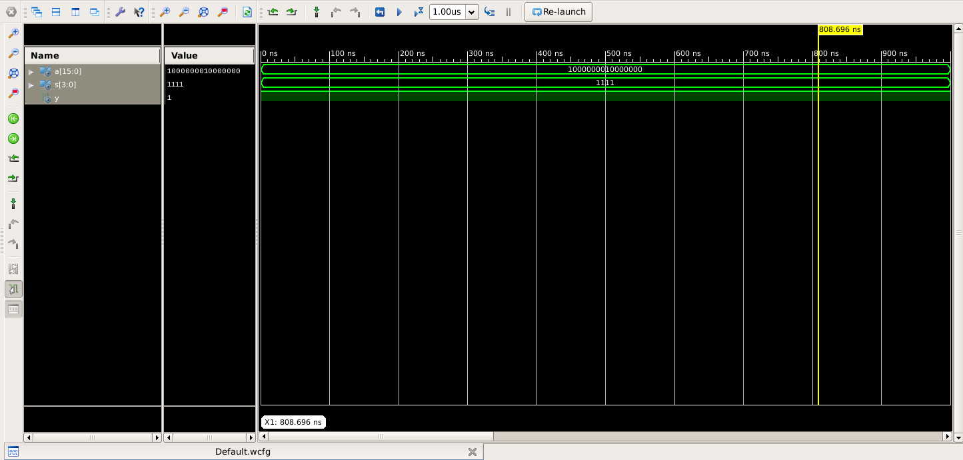
Proof That it Was Not Copied
You can check My Github Account
https://github.com/ij-roy/Semester-3/tree/main/COA/Assignment%202
I had uploaded Every picture and code used above and you can also check the Date of Upload

Thank You

